1. **Abstract Use Cases:**

UC1: Input Description(Actor: User, System: RAT)

UC2: Identify Verb-Noun Phrases(Actor: User, System: RAT)

UC3: Classify verb-noun Phrases(Actor: User, System: RAT)

UC4: Generate Requirements(Actor: User, System: RAT)

UC5: Modify Requirements(Actor: User, System: RAT)

UC6: Save Requirements(Actor: User, System: RAT)

1. **High Level Use Cases:**

UC1: Input Description

TUCBW The user clicks on the import button or places the cursor on the textbox.

TUCEW The user imports a file or types in the description manually as the input.

UC2: Identify Verb-Noun Phrases

TUCBW The user clicks on the highlight button.

TUCEW The user highlights the verb-noun phrases manually.

UC3: Classify verb-noun Phrases

TUCBW The user right clicks on the verb-noun phrases.

TUCEW The user classifies into business processes, steps and actions.

UC4: Generate Requirements

TUCBW The user clicks on the generate button.

TUCEW The user views the generated requirements.

UC5: Modify Requirements

TUCBW The user clicks on the text and modify it.

TUCEW The user modifies the requirements.

UC6: Save Requirements

TUCBW The user clicks on the save button.

TUCEW The user gets a saved file.

1. **Use Case Diagram:**

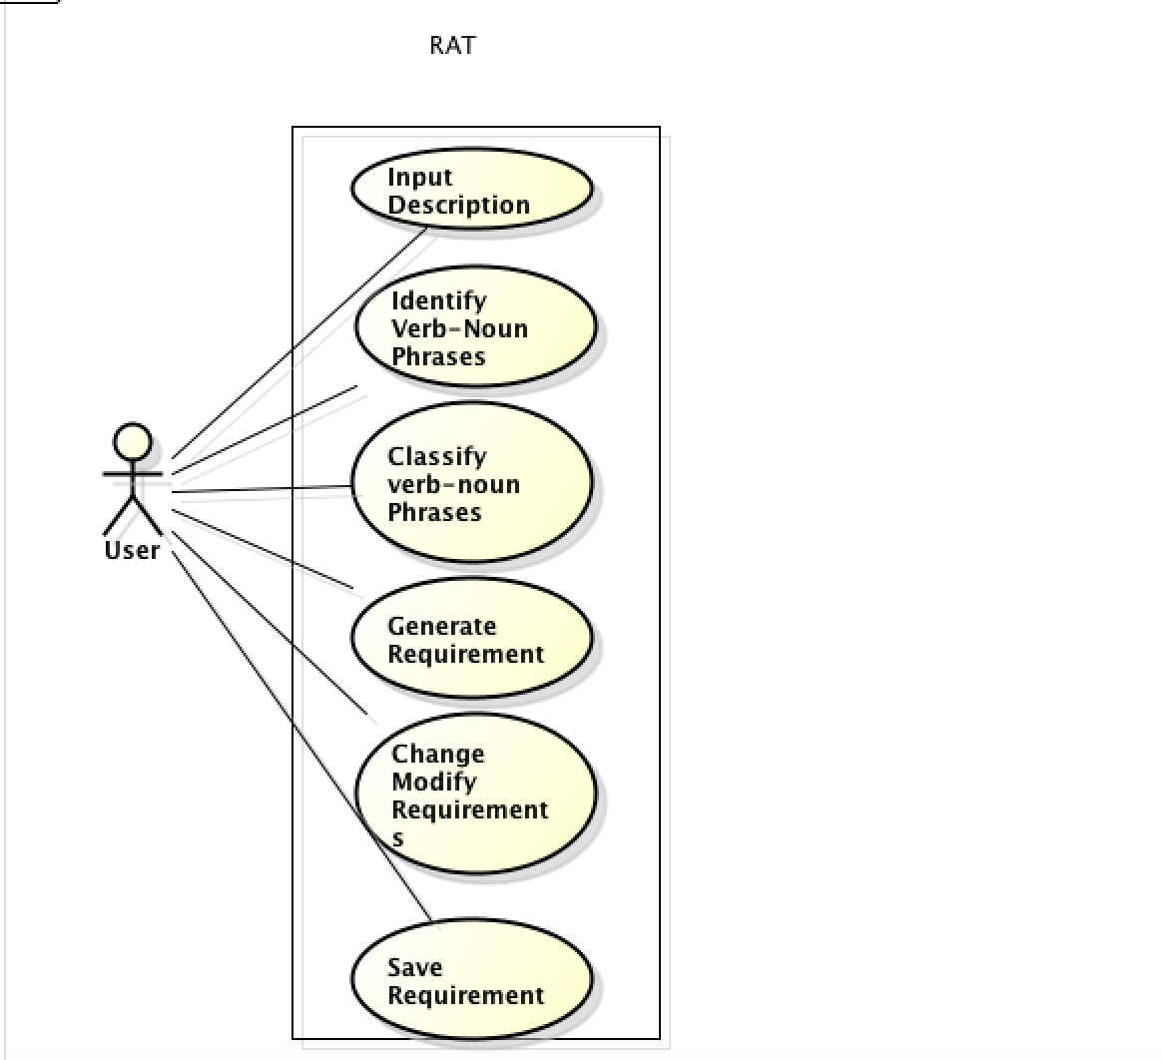

1. **Use Case SpreadSheet:**

|  |  |  |  |  |  |  |  |
| --- | --- | --- | --- | --- | --- | --- | --- |
| Verb-Noun Phrase | Is this a business process? | Does it begin with an actor? | Does it end with an antor? | Does it accomplish a business task for the actor? | Is it a use case? | Actor | Subsystem |
| Input Description | Y | Y | Y | Y | Y | user | RAT |
| Identify Verb - Noun phrase | Y | Y | Y | Y | Y | user | RAT |
| Classify Verb- noun phrase | Y | Y | Y | Y | Y | user | RAT |
| Generate requirement | Y | Y | Y | Y | Y | user | RAT |
| Display Requirements | N | N | N | Y | N | NA | NA |
| Modify requirements | Y | Y | Y | Y | Y | user | RAT |
| Save requirements | Y | Y | Y | Y | Y | user | RAT |